SQair

Renson Ventilation, IZ 2 Vijverdam, Maalbeekstraat 10, 8790 Waregem – Belgium
Tel. +32 (0)56 62 71 11, fax. +32 (0)56 60 28 51, info@renson.be www.renson.eu
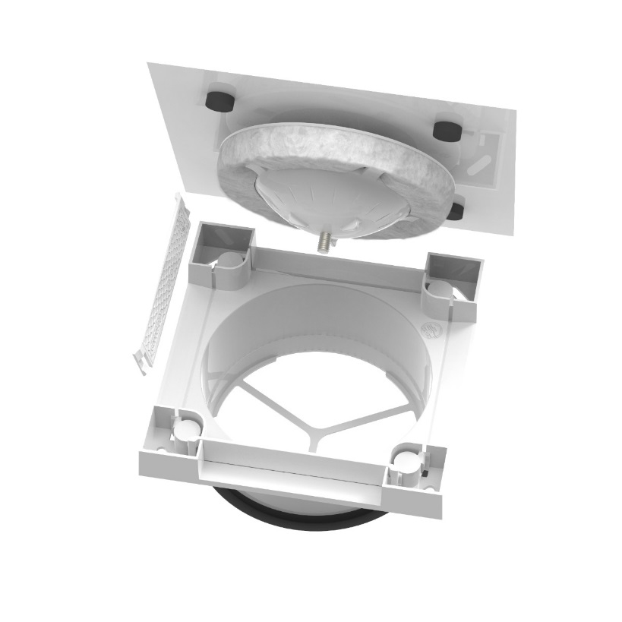
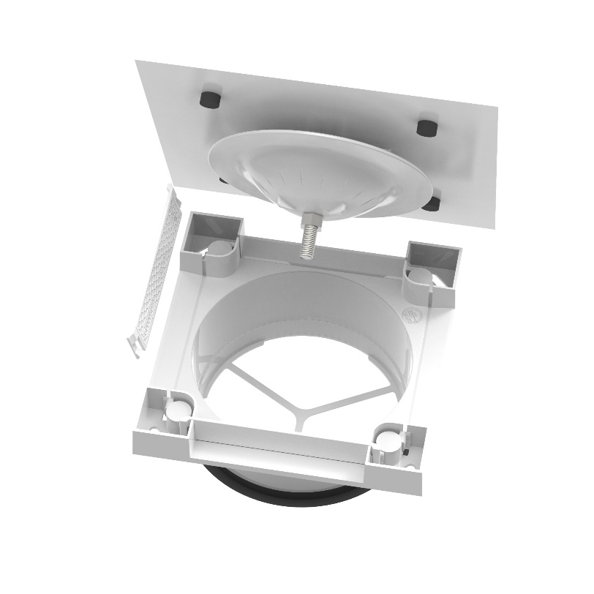

dESCRIPTION

- Adjustable valve available in 4 versions
  - Extraction valve:
    - Basic: synthetic front plate RAL 9010 (coloured plastic)
    - Deluxe: Aluminium front plate (lacquered RAL 9010)
  - Pulse valve:
    - Basic: synthetic front plate RAL 9010 (coloured plastic)
    - Deluxe: Aluminium front plate (lacquered RAL 9010)
- Construction: grid base + front plate
- Protrudes only 24mm from the ceiling of wall.
  - The wider front plate conceals the ventilation openings.
- Direct connection onto the air ducts
  - Ø125mm
  - Integrated rubber gasket: airtight connection
- Front plate:
  - Basic: Snaps on the grid base
  - Deluxe: Attached with magnets to the grid base
  - Easily disassembled for cleaning
  - Thanks to the locknut the settings remain during cleaning
- The Pulse valve has 2 deflectors
  - 2 of the 4 ventilation openings can be closed using the deflectors.
    - For example: If the valve is installed close to a wall, this side can be closed to prevent the accumulation of dust.
- The pulse valve is provided with acoustic material
  - Prevents whistling noise at the valve

Product features

 | BASIC | DELUXE
Front plate | ASA | Aluminium
Measurements front plate | 170 x 170mm | 180 x 180mm
Measurements grid base | 150 x 150mm | 150 x 150mm
Colour | RAL 9010 | RAL 9010
Attachment | Snap-on | Magnets
Paintable | - | Yes
Deflectors | - | 2
Measurements deflector | 92 x 20mm | 92 x 20mm

